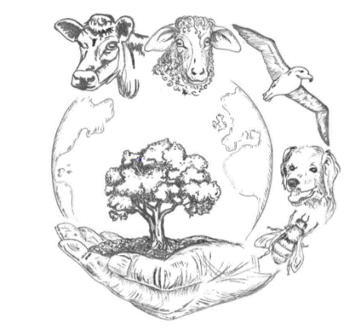
Mining Diamonds
VPHA & AGV Spring Conference 2020

14th March 2020,
Leicester college court
https://collegecourt.co.uk

UNDERGRADUATE STUDENT POSTER COMPETITION

Applications are invited from veterinary students: *Deadline for submission 1st March 2020*
Posters/talks may be in the following categories:
Conceptual Ideas
Research ideas or proposals, theoretical concepts, policy or discussion points
Research
Quantitative, qualitative, lab-based, public health or animal health/welfare related

- Free full conference attendance for TWO undergraduate student per vet school presenting a poster
- For other undergraduate students, day attendance £40, full attendance - see registration form

Posters
- No bigger than A0 and ideally no smaller than A1
- A vertical display board will be provided
- The posters that attract most attention in the above categories (‘the winning posters’) may get a chance to present these to the audience in a Blitz talk!
Blitz talk
- No longer than 2-3 minutes, Max 3 slides with a brief outline of your topic together with the overall impact or perceived impact on humans, non-human animals and/or the environment.

Resources available to help making academic posters: https://libguides.ncl.ac.uk/acadaemicposters
Please fill in the details below and send to Rhiannon Wood (rmw40@cam.ac.uk) and Peter Moore (petermoore333@gmail.com) with a photograph or hyperlink to a photograph. If you would like to discuss your topic or have any questions, please do not hesitate to contact us.

Name and current affiliation
Contact details including email
Title of poster/talk
Brief outline of poster/talk

