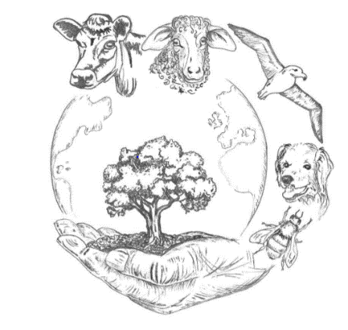
REGISTRATION FORM FOR VPHA and AGV AUTUMN CONFERENCE 2020

MINING DIAMONDS
Bringing together gems of the past, present and future to celebrate the VPHA’s 60th anniversary virtually

Send completed forms to: simon.woliter@eandj.co.uk
Name, Surname
Email address:
Tel number (optional)
Non-undergraduate (vets and non-vets)/Undergraduate (please delete as appropriate)
VPHA/AGV member/ not a member of either VPHA or AGV (please delete as appropriate)
Discussion Sessions run by UK vet student. For non-undergraduates (vets and non-vets) only. | I would /would not like to attend one of the small group discussion sessions during the conference week.  (please delete as appropriate)
If you would like to attend one of the small group discussion sessions, please select a session you wish to join
(please delete as appropriate)

- Non-undergraduate session A. Saturday 10 October 10-12 am
- Non-undergraduate session B. Monday 12 October 9-11 am
- Non-undergraduate session C. Wednesday 14 October 3-5 pm
- Non-undergraduate session D. Thursday 15 October 3- 5 pm

If you would you like to be named in the credits of a report written on the outcome of the virtual conference, please indicate:
Yes/No
(please delete as appropriate)

Details for joining the sessions will be circulated following registration.
Final conference session on Saturday 17th October 2-4pm  (for all conference delegates) | If you will be able to attend the final live conference discussion, please indicate:  Yes/No  (please delete as appropriate)
Free VPHA&AGV Conference but donations are actively encouraged!

The suggested amount is £20 or more if you wish. Proceeds will go towards student VPHA activities.

PayPal link for voluntary donations. You do not have to have a PayPal account to contribute, just click on the link and you will be directed to payment page.

https://www.paypal.com/cgi-bin/webscr?cmd=_s-xclick&hosted_button_id=VYFW8BVLFNDSN&source=url

